Linux Command :
Linux is a Unix-Like operating system. All the Linux commands are run in the terminal provided by the Linux operating system. This terminal is just like command line of Windows OS etc . The commands of Linux are case sensitive. The terminal can be used to accomplish all administrative tasks. This includes software installation, file manipulation, and user management. Linux terminal is user-interactive interface . The terminal shows the results of commands which are given by the user . Execution of typed command is done only after press the Enter key.

Basic Linux command :

1) pwd command
‘pwd’ command prints the absolute path to current working directory.

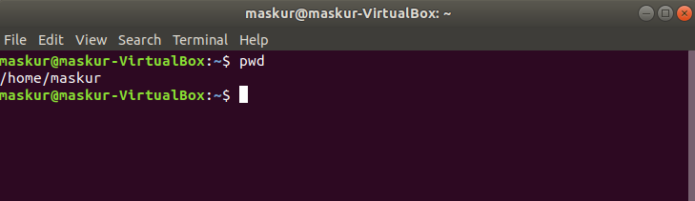

2) cal command
Displays the calendar of the current month.
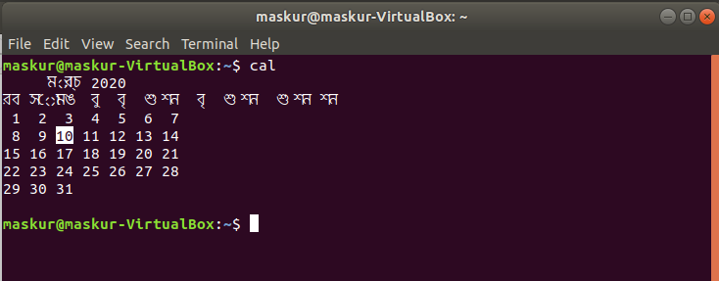

3) echo command
This command will echo whatever we provide it.
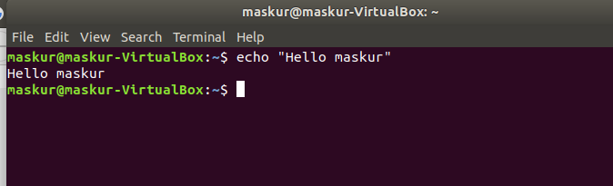
This echo variable is use to display the values of a variable .To check the value of a variable precede the variable with a $ sign.
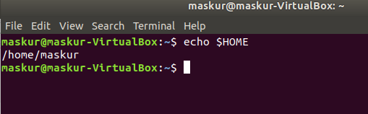

4) date command
Displays current time and date.
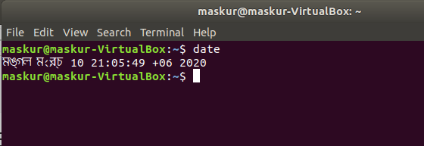

5) tty command
Displays current terminal.
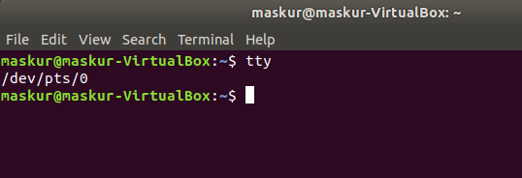

6) whoami command
This command reveals the user who is currently logged in.
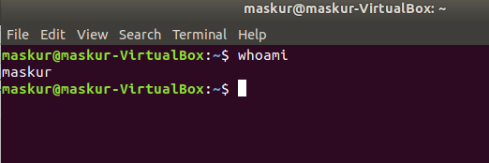

7) id command
This command prints user and groups (UID and GID) of the current user.
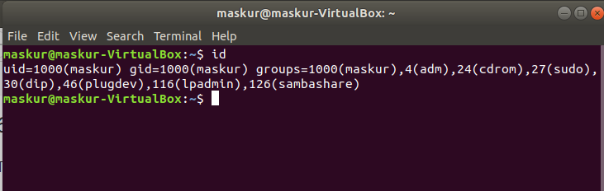

7) man command
Man command in Linux is used to display the user manual of any command that we can run on the terminal.
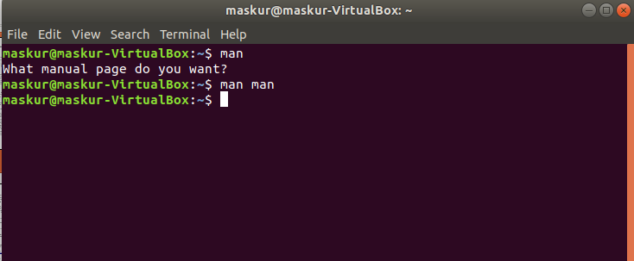

9) help option
Nobody can remember all the commands . So we can use help command.
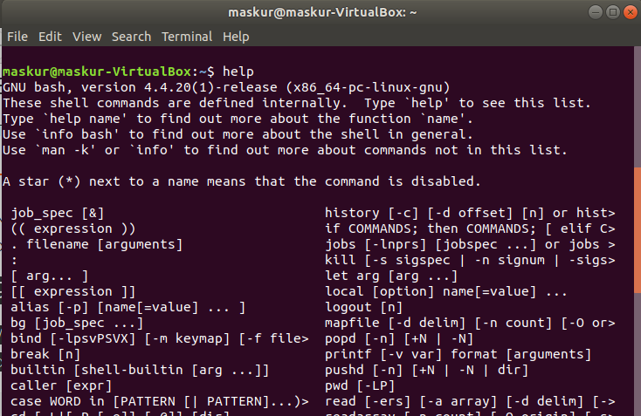

With almost every command, ‘--help’ option shows usage summary for that command.
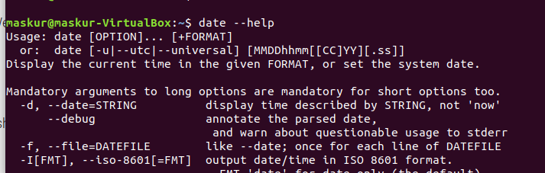

10) whatis command
This command gives a one line description about the command. It can be used as a quick reference for any command.
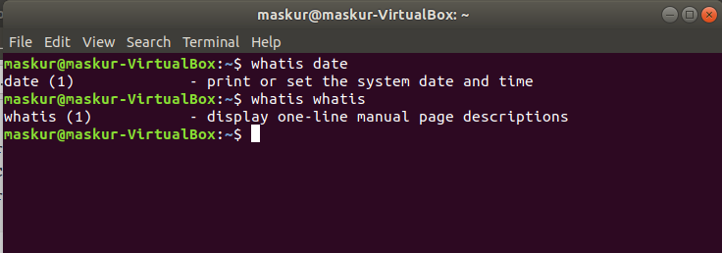

11) Manual Pages
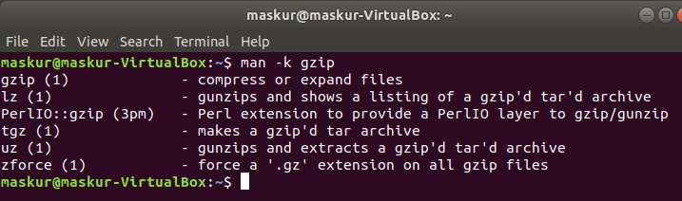
‘--help’ option and ‘whatis’ command do not provide thorough information about the command. For more detailed information, Linux provides man pages and info pages. To see a command's manual page, man command is used.

12) Info pages
Info documents are sometimes more elaborate than the man pages. But for some commands, info pages are just the same as man pages. These are like web pages. Internal links are present within the info pages. These links are called nodes. Info pages can be navigated from one page to another through these nodes.
$ info date

13) Changing Directories Command
$ cd [path-to-directory]
Change the current working directory to the directory provided as argument. If no argument is given to ‘cd’, it changes the directory to the user's home directory. The directory path can be an absolute path or relative to current directory. The absolute path always starts with /. The current directory can be checked with ‘pwd’ command (remember?)
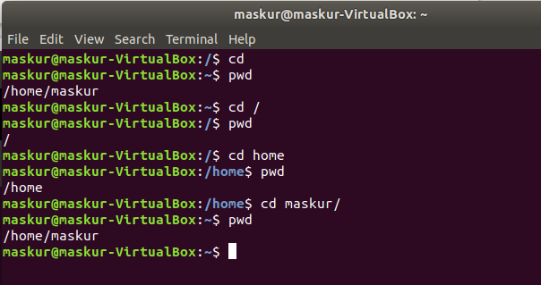

14) Listing File And Directories Command
$ ls [files-or-directories]
List files and/or directories. If no argument is given, the contents of current directory are shown.
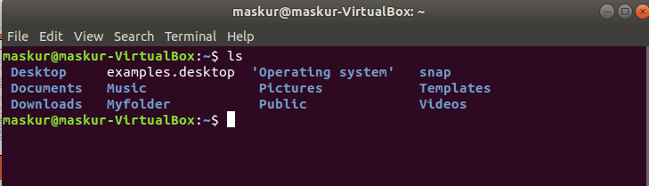
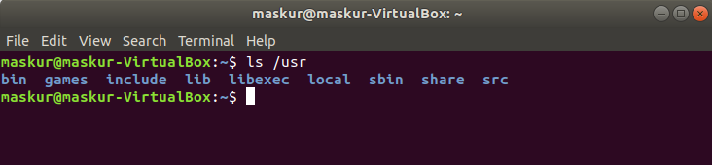
if a directory is given as an argument, files and directories in that directory are shown.

‘$ ls -a ‘ command is use to show the hidden files-or-directories
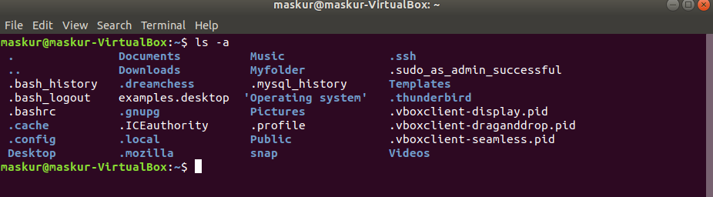

15) mkdir command
To create a directory, the ‘mkdir’ command is used.
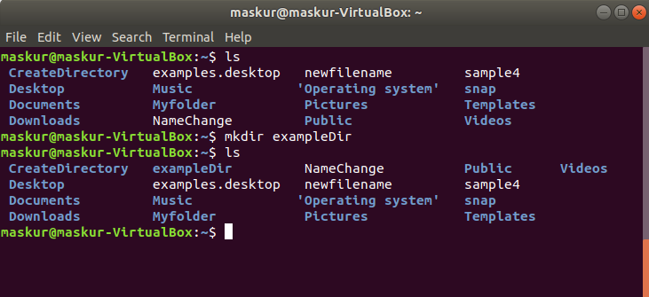

16) To remove or Delete
$ rm directory name
'rmdir' command removes any empty directories, but cannot delete a directory if a file is present in it. To use ‘rmdir’ command, you must first remove all the files present in the directory you wish to remove (and possibly directories if any).
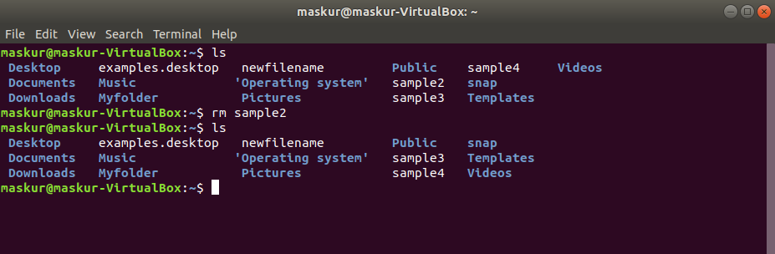

16) cat command
‘cat’ command is used to create file and used to view the content of a file.
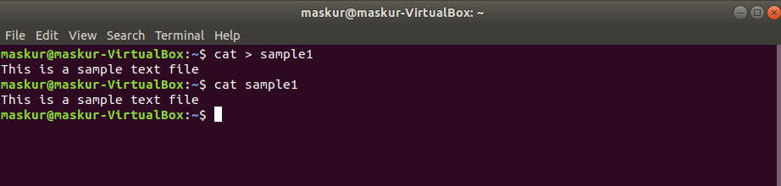

17) ip command
It shows the ip adderess
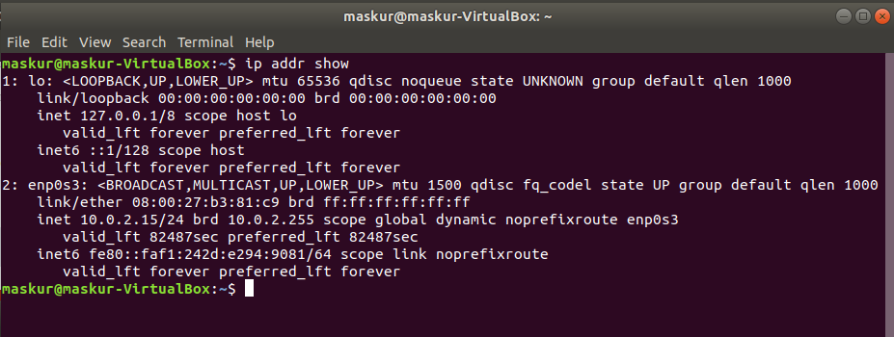

18) mv command
‘$mv ‘ command use to change the files-or-directories name
